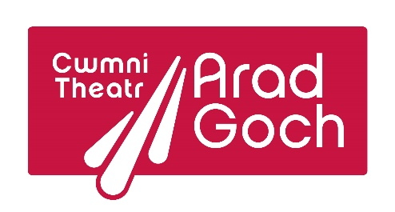
Canolfan Arad Goch
Bath Street, Aberystwyth
Cymru, SY23 2NN
+44 (0) 19708 617998
www.agordrysau.cymru
@aradgoch

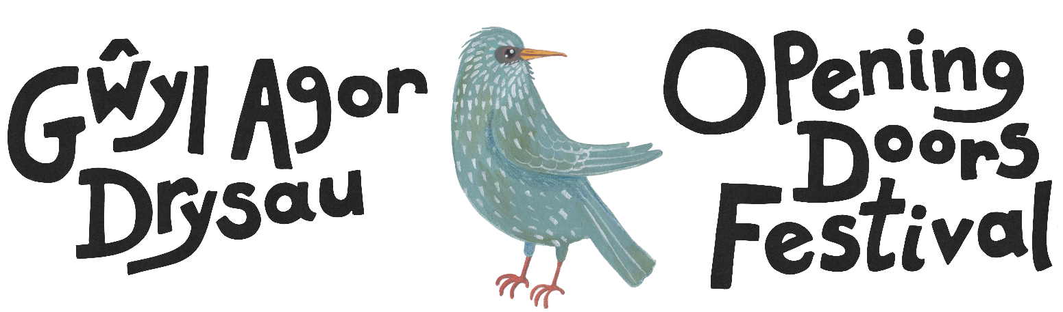

12 – 16 Mawrth / March 2024
Wales’ International Theatre Festival for Young Audiences

Next Generation Placement
Application form

Cwmni Theatr Arad Goch is offering a placement opportunity to join the festival team for two months, from mid-January until 16th March 2024.
As part of a small team, the successful candidate will assist with organising the festival.
Responsibilities could include:
- providing marketing support e.g., updating the festival website, designing promotional material, photography, and blogging.
- liaising with the production companies, delegates and venues.
- providing Box Office support.
- monitoring and evaluation.

We will provide:
- Accommodation: on a sharing basis, will be provided for free throughout the length of your stay.
- Daily meal allowance: as per ITC guidelines https://www.itc-arts.org/rates-of-pay/
- Travelling: transport from / to the UK airport, local transportation, and if required, a contribution towards flight costs.

You will be responsible for arranging your own transport to the UK and, if necessary, for arranging visas, permits etc.
The programme for the festival will be announced soon. Details of the last festival in 2019 can still be seen on http://agordrysau-openingdoors.org.uk/

The festival is organised by Cwmni Theatr Arad Goch and is funded by the Arts Council of Wales. It operates:
- to enable UK audiences to see some of the best international theatre;
- to enable International theatre practitioners and students to meet, discuss and network;
- to promote British theatre to a wider audience.

Your Personal details:
First name:
Last name:
Address:

Phone number:
e-mail address:
Website / Blog:
Date of Birth:
Place of Birth:
Nationality:
Country of Residence:
Passport Number:
Languages spoken:

ASSITEJ Experience
Are you a member of an ASSITEJ National Centre? | Yes | No
Are you a member of an ASSITEJ Professional Network? | Yes | No
Please specify which National Centre and / or Network:

Do you have any previous experience in the ASSITEJ programmes? | Yes | No
Please specify which programme:

Motivation & Previous Experience
Why are you applying for this placement?

Are there any specific areas of work you would like to be involved with during your placement?

How will this placement benefit your future aspirations?

CV
Please provide a CV with your application.
Travelling contribution
We do not wish for the cost of travelling to be a barrier, therefore, could you please note how much of a contribution you may require towards travelling costs.

Accessibility
Do you have any access, dietary or any additional requirements you would like us to be aware of?

YES NO
If YES, please note your requirements:

Comments or Questions

Closing date: 17th November 2023

