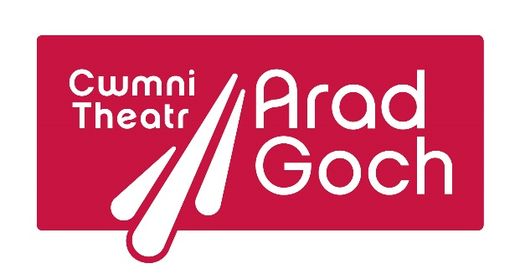

Gŵyl Agor Drysau | Opening Doors Festival
12-16 March 2024
Wales’ International Theatre Festival for Young Audiences

Production details
Company
Full address
Contact person
E-mail address
Phone number (including international dialing code)
Website
Title of production
Language(s) of production
Writer
Director
Design
Cast (including nationality, for visa purposes)

Other creatives
Short description (200 words)
Running time
Audience age range
Maximum audience number
Type of performance space (proscenium theatre, studio, school hall, outdoors etc.)
Stage dimensions (width, depth, height)
Sound requirements
Lighting requirements
Get-in time needed
Get-out time needed
Any other technical information
Cost of two performances (both performances on the same day or on two consecutive days)
Would you be interested in an additional performance in a different town / venue, other than Aberystwyth?
Cost of an additional performance in a different town / venue
How do you travel as a company / production?
Number of people travelling
Accessibility needs or requirements for any of the people travelling
Approximate travel costs
Other costs
Is it possible for you to apply for funding for your travel and any other costs from your government / region / arts council / other organisation (please note the name of the funding organisation)
Are you available to be in Aberystwyth / Wales between 12-16 March 2024? (please note any days you are not available)
Would you be available in the days before or after the festival, should you be interested in an additional performance?
Please provide links to videos and high-quality marketing images for the production (we’d prefer to see a full video of the production, not just a trailer. It doesn’t matter if this video is low-quality)
Would you be interested in, and able to lead workshops for children / young people / students / professionals / other? (please provide information)
Any further information or requirements
Please return this document by 21 August 2023 to: Steffan Phillips, Opening Doors Festival Producer steffan@aradgoch.org
For further information about the festival, including previous programmes, visit www.openingdoors.wales

